### **Day 2**

### **Git Project**

#### **Objective:**

You will work on a project involving a simple website. You will learn and practice various Git concepts including branching, merging, handling merge conflicts, rebasing, pulling, versioning, and rolling back changes.

#### **Project Setup**

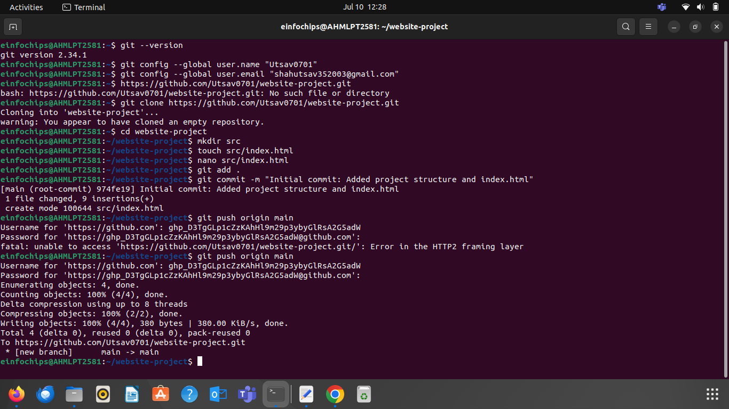

#### **Exercise 1: Branching and Basic Operations**

**Create a New Branch**:

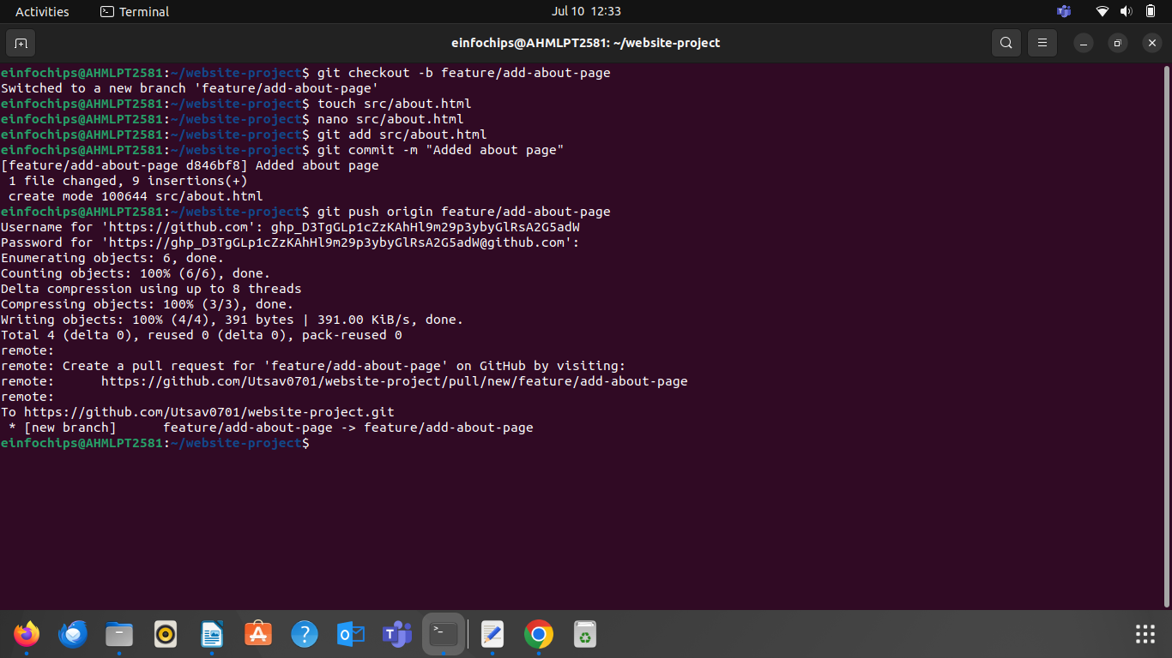

#### **Exercise 2: Merging and Handling Merge Conflicts**

**Create Another Branch**:

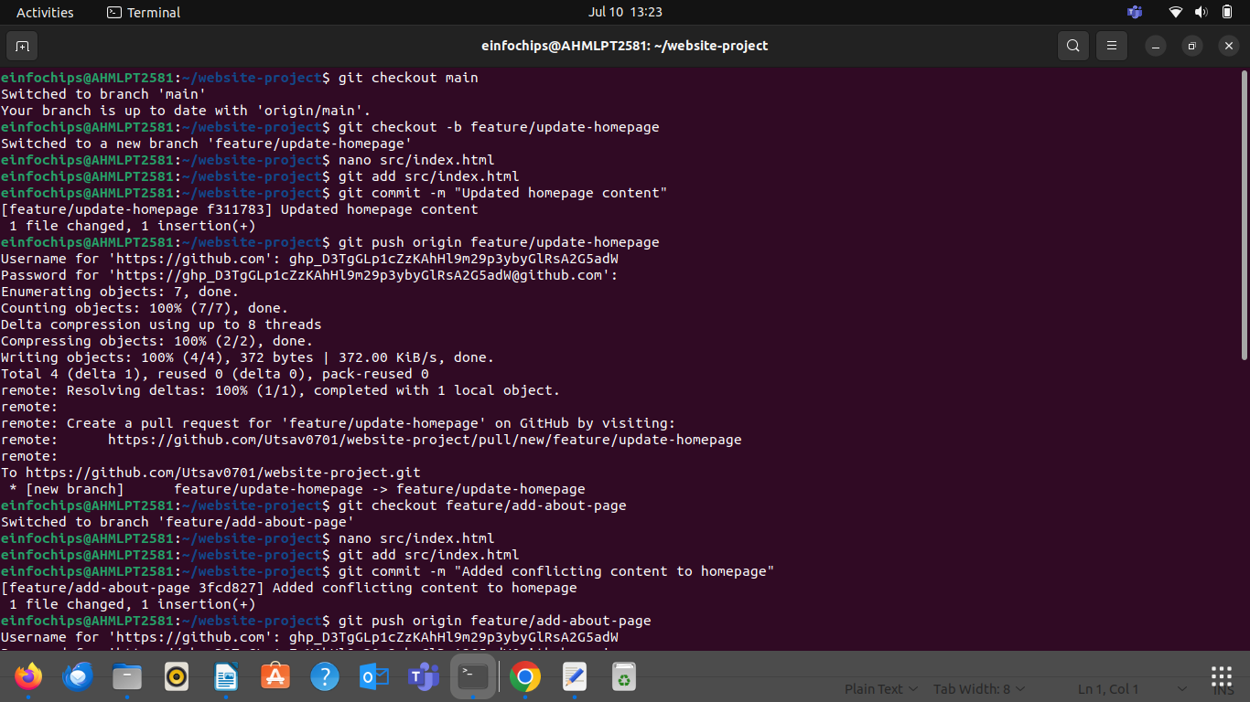

#### 

#### **Exercise 3: Rebasing**

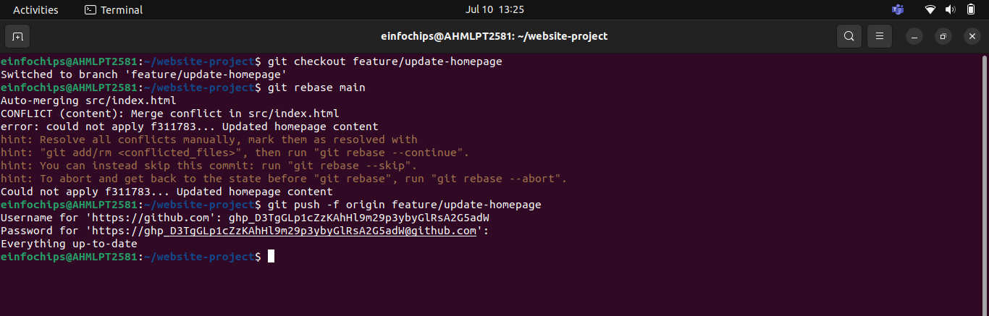

#### **Exercise 4: Pulling and Collaboration**

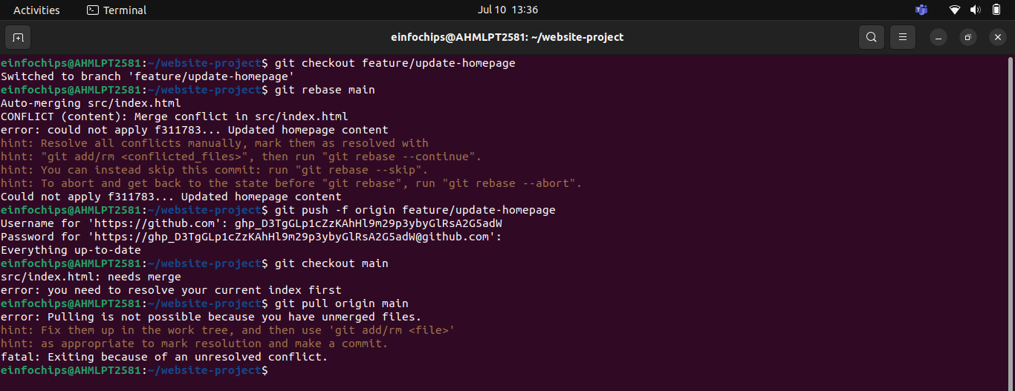

#### **Exercise 5: Versioning and Rollback**

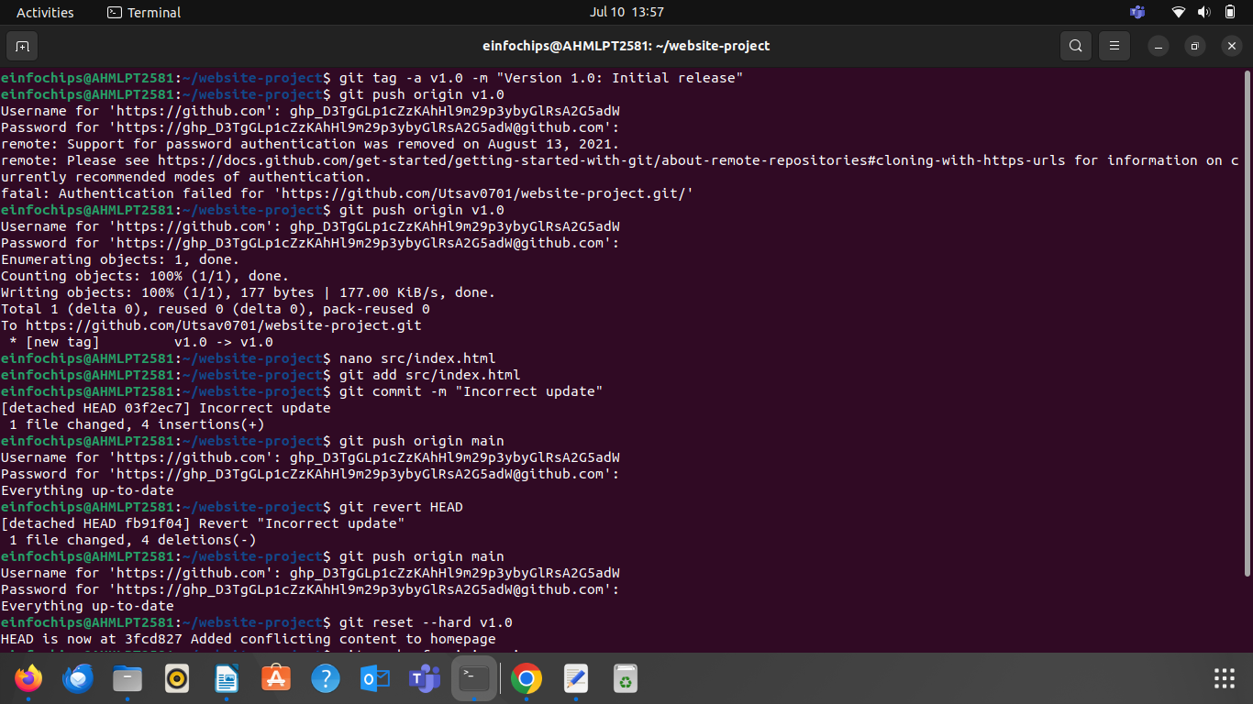

#### 

### **Collaborative Blogging Platform**

#### **Objective:**

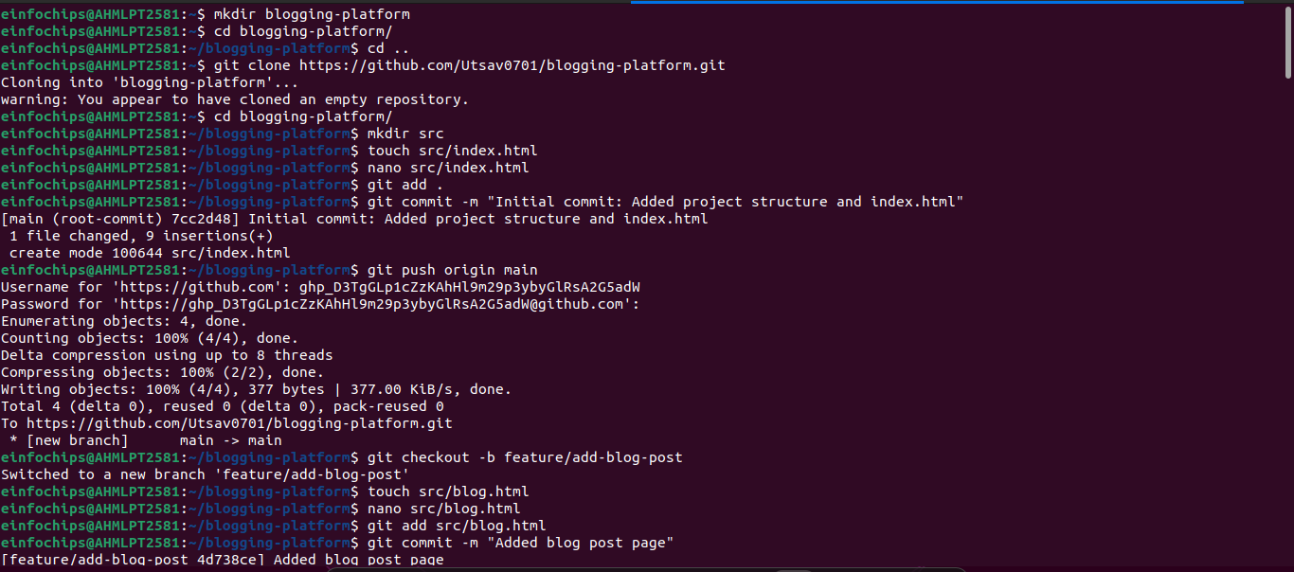

#### **Exercise 2: Collaborating with Merging and Handling Merge Conflicts**

**Create Another Branch for Author Info**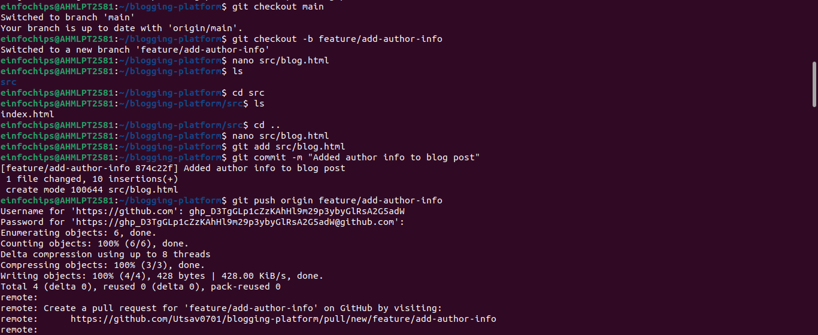:

#### **Exercise 3: Rebasing and Feature Enhancement**

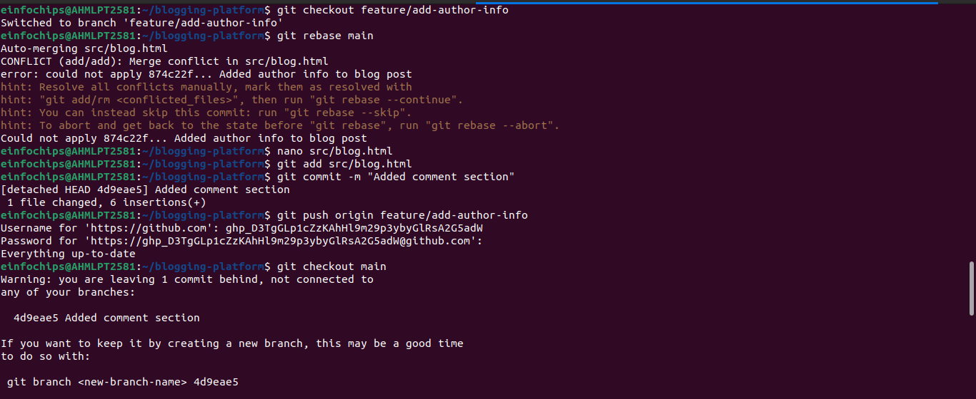

#### **Exercise 4: Pulling and Simulating Collaboration**

1. **Pull Changes from Remote**:

Ensure the main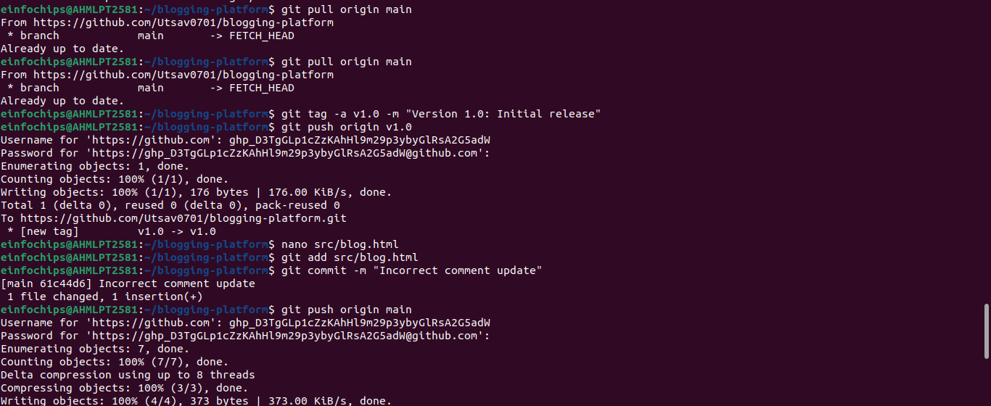 branch is up-to-date:

1. **Revert to a Previous Version**